**EBAZAAR Application**

Ebazaar landing page

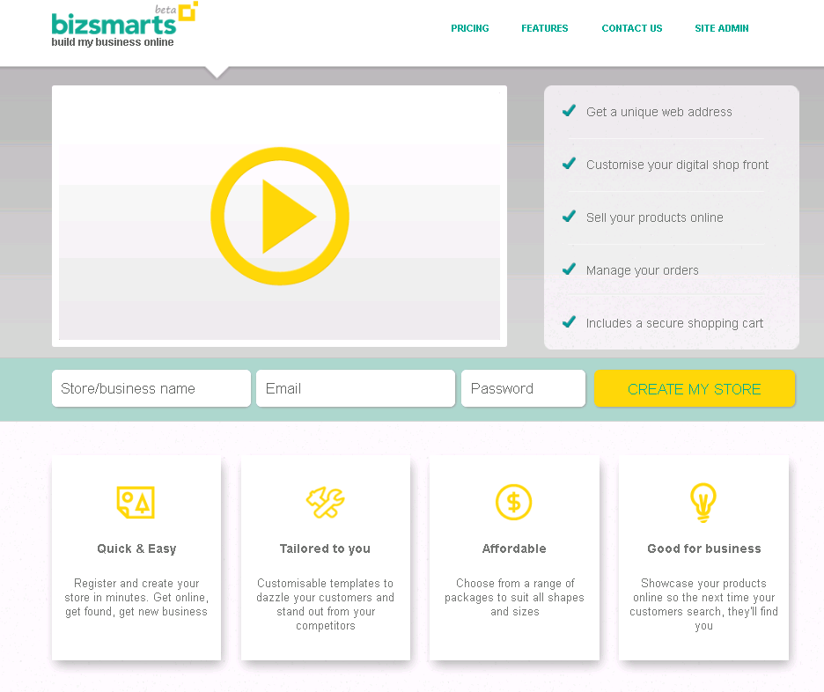

Ebazaar pricing plan for end customer. They can select any of below mentioned plans to create websites

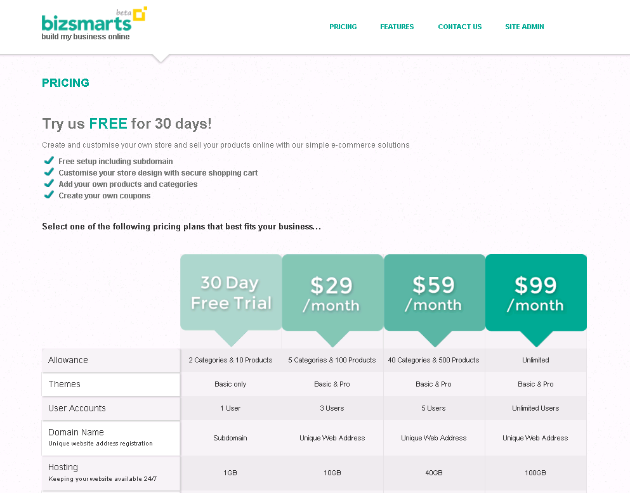

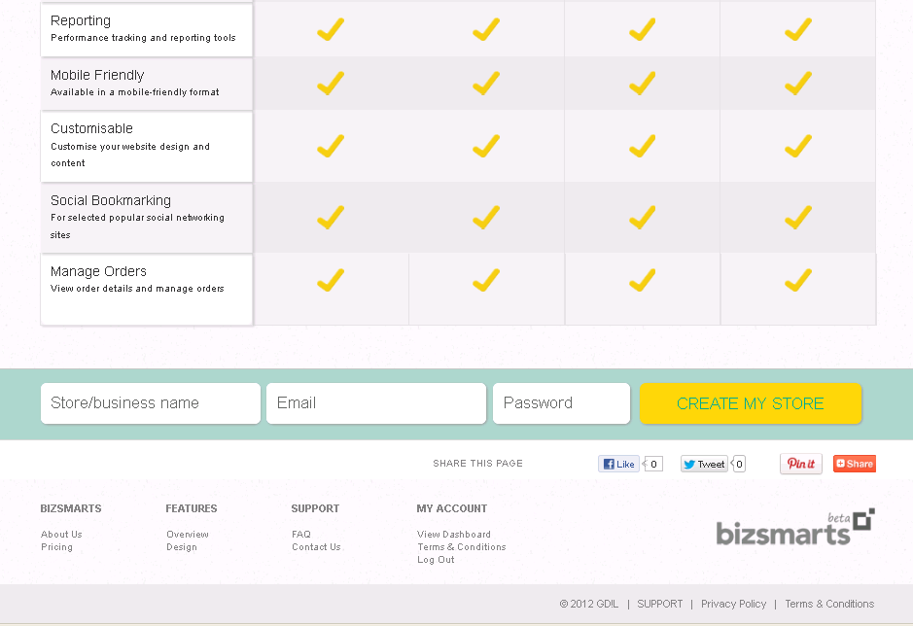

End customer can send mail to bizsmart support ppl for their queries

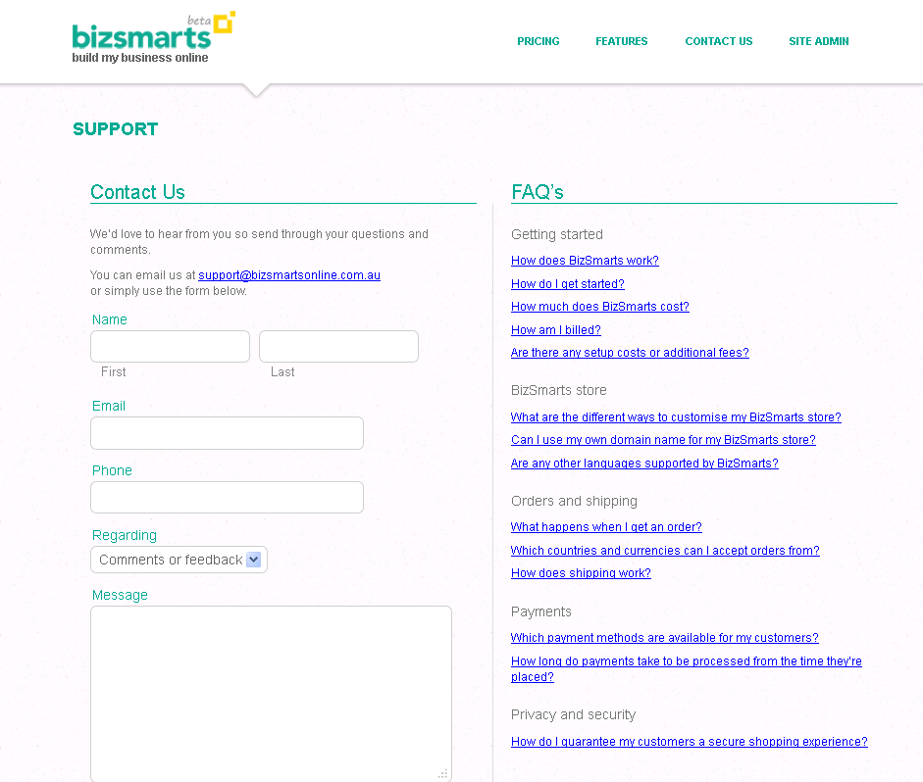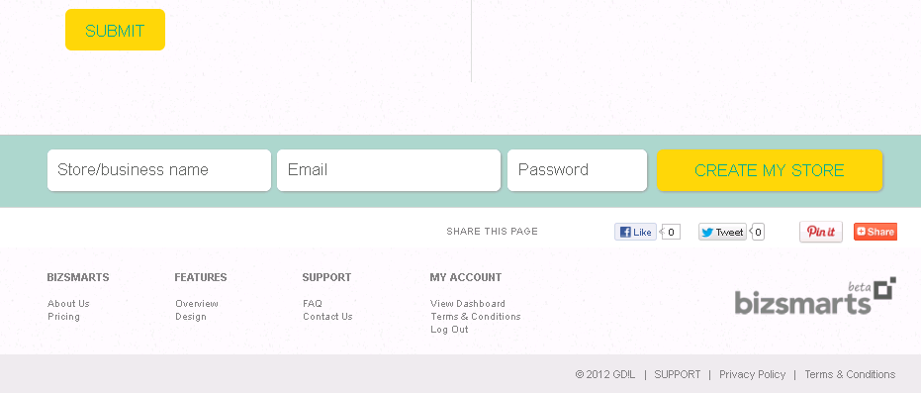

Bizsmarts login page for end customer who is having the websites .This login page is a admin console for bizsmarts customers . They can go to their website after successful login and make changes for look and feel of their websites

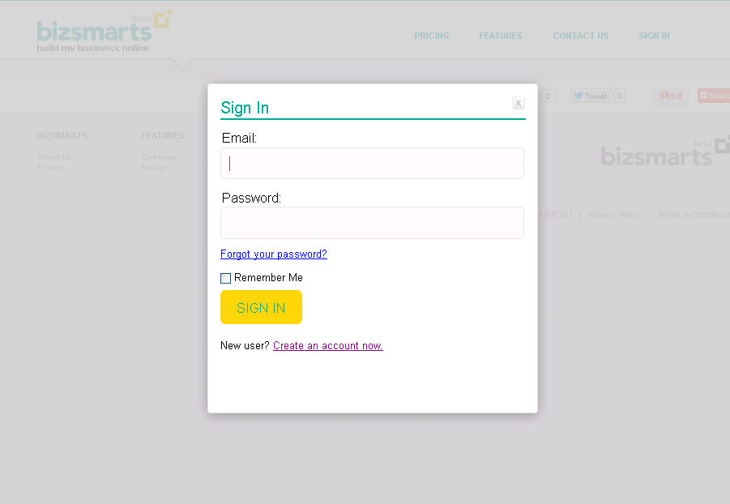

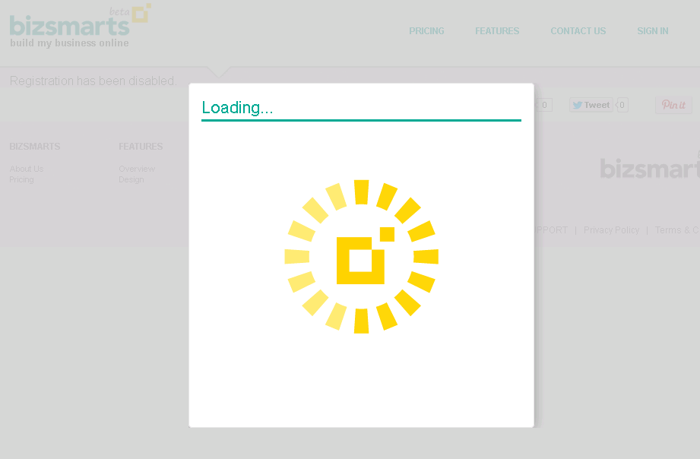

End customer website sample

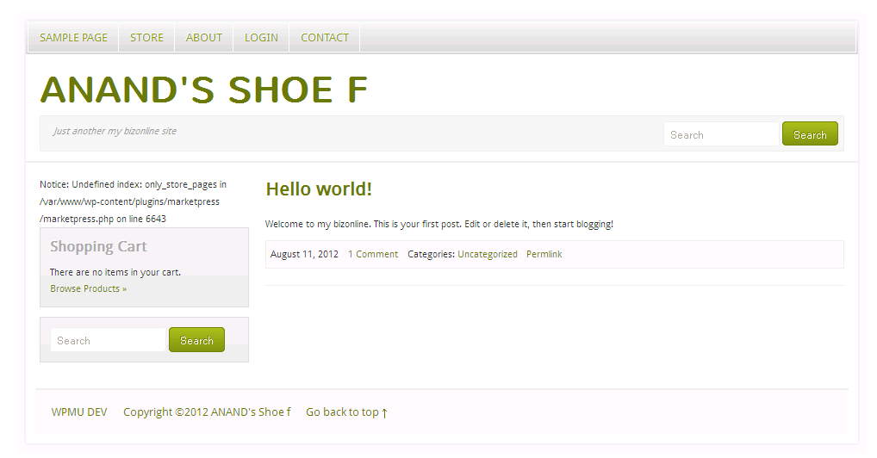

End customer is having a website to sell shoes online

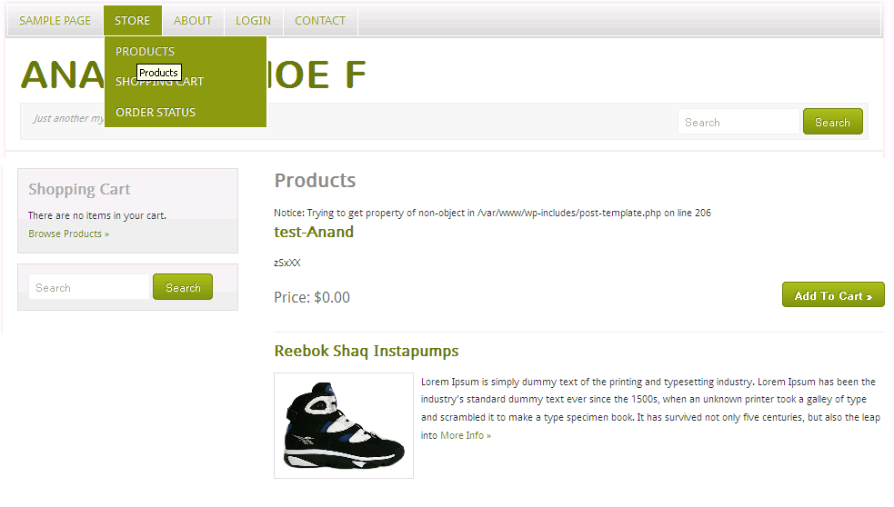

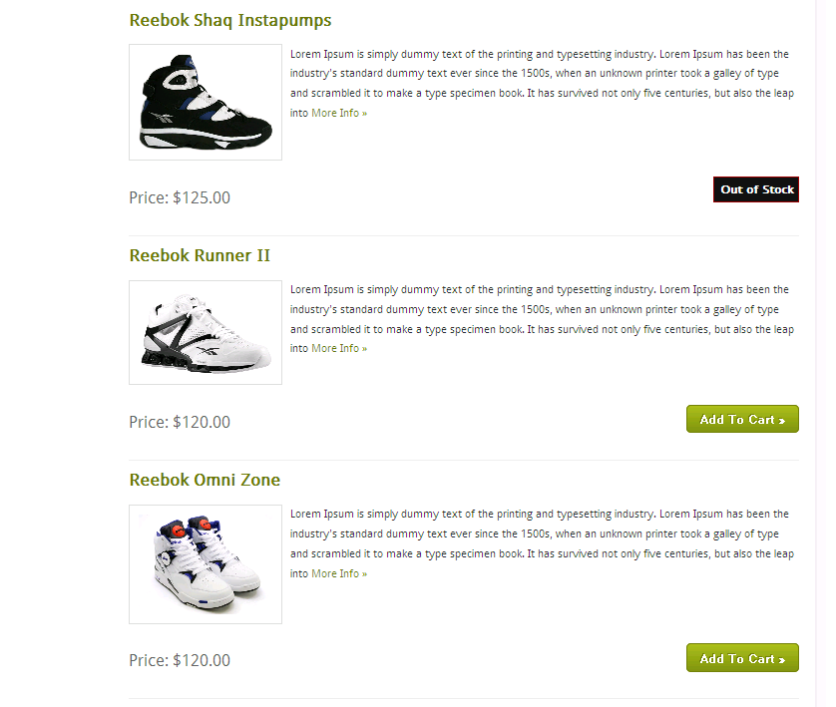

Customers can buy the products

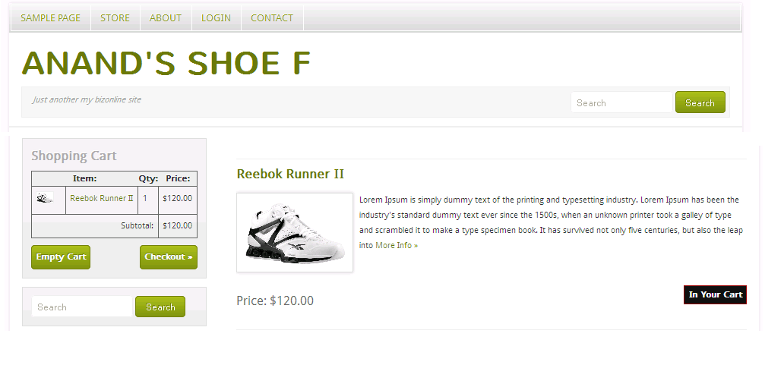

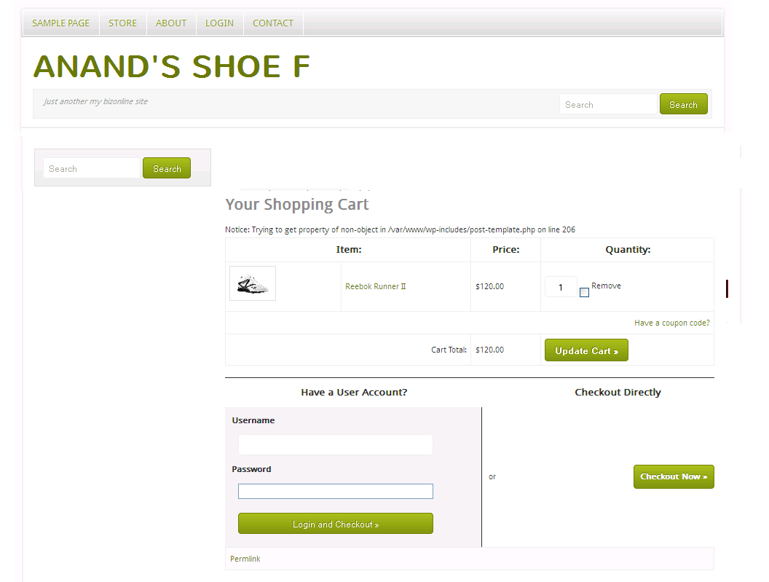

After clicking on checkout , user has to fill their details

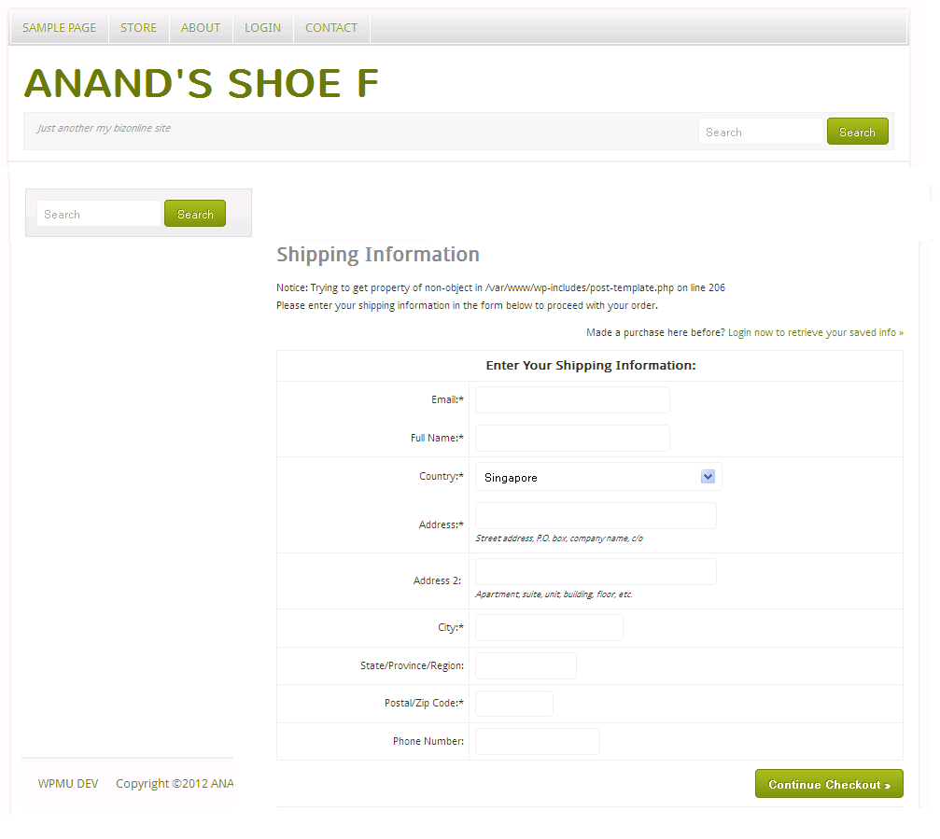

Customer can track the order

